**Simulation of ODE using matlab**

**Lab report #05**



Fall 2022

CSE-310L Control Systems

Submitted by: **Ashfaq Ahmad**

Registration No: **19PWCSE1795**

Class Section: **B**

“On my honor, as student of University of Engineering and Technology, I have neither given nor received unauthorized assistance on this academic work.”

Student Signature: ______________

Submitted to:

**Dr: Muniba Ashfaq**

**NOV** 09, 2022

**Department of Computer Systems Engineering**

**University of Engineering and Technology, Peshawar**

**Objective(s):**

* **To learn about functions ode23 and ode45.**
* **To learn How to solve ODE in using matlab.**

**Ode23:** It is used for lower order differential equation.

**Syntax**: **[t,y]=ode23(odefun,tspan,y0)**

Where tspan = [t0 tf], integrates the system of differential equations *y*′=*f*(*t*,*y*) from t0 to tf with initial conditions y0. Each row in the solution array y corresponds to a value returned in column vector t.

**Ode45:** It is used for higher order differential equation.

**Syntax:** **syntax is same as ode23.**

**Task01:** Solve the following system of ordinary differential equation.

**y1’ = y2*y3 y1(0)=0,**

**y2’’= -y3*y2 y20)=1,**

**y3’’’= -0.51*y2*y1 y3(0)=1,**

**t0=0 , tf=40**

**Source code:**

function dy=task01(t,y)

dy=zeros(3,1);

dy(1)=y(2)*y(3); %dy(1) represnt first order derivative

dy(2)=-y(3)*y(1); %dy(2) represnt 2nd order derivative

dy(3)=-0.51*y(2)*y(1); %dy(3) represnt 3rd order derivative

end

**Command window:**

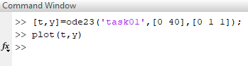

**Plot:**



**Task02:** Solve the following ordinary differential equation.

**y’’+y2y’-y’+y=0**

**y’(0)=0, y’’(0)=12**

**t0=0, tf=40**

**Source code:**

function dy=task02(t,y)

dy=zeros(2,1);

dy(1)= y(2); (First order derivative is equal to y(2),2nd order is equal to y(3) and so on)

dy(2)= -y(1)*y(1)*y(2)+y(2)-y(1);

(for higher order derivative we will shift all term to right will replace derivative with corresponding function)

end

**Command window:**

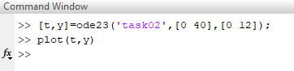

**Plot:**



**Task03**: Solve the following ordinary differential equation.

**yv+2yiv +24y’’’+48y’’+24y’ +20y+10=0**

**y(0)=2, y’(0)=5, y’’(0)=10, y’’’(0)= - 4, yiv(0)= -7**

**t0=0 , tf=40**

**Source code:**

function dy=myfun(t,y)

dy=zeros(5,1);

dy(1)=y(2);

dy(2)=y(3);

dy(3)=y(4);

dy(4)=y(5);

dy(5)= -2*y(5)-24*y(4)-48*y(3)-24*y(2)-20*y(1)-10;

end

**Command window:**

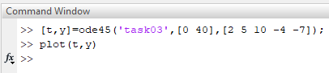

**Plot:**



**Task04:** Solve the following ordinary differential equation.

**yvii +5yvi +20yv+2yiv +24y’’’+48y’’+24y’ +20y+10=0**

**y(0)=2, y’(0)=5, y’’(0)=10, y’’’(0)= -4, yiv(0)= -7, yv(0)=9, yvi(0)= -20**

**t0=0 , tf=40**

**Source code:**

function dy=task04(t,y)

dy=zeros(7,1);

dy(1)=y(2);

dy(2)=y(3);

dy(3)=y(4);

dy(4)=y(5);

dy(5)=y(6);

dy(6)=dy(7);

dy(7)=-5*y(7)-20*y(6)-2*y(5)-24*y(4)-48*y(3)-24*y(2)-20*y(1)-10;

end

**Command window:**

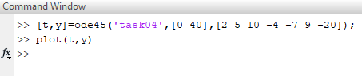

**Plot:**

